**Cross-Browser Compatibility Testing Report**

**Project Name:** Random Quote Generator SPA  
**Test Date:** [10/15/2024]

**Tested By:** M. Faseeh Hassan

**Overview :**

This document summarizes the cross-browser compatibility test results for the Random Quote Generator application. The goal was to ensure that the web application behaves consistently across a variety of popular web browsers.

**Test Summary:**

|  |  |  |  |
| --- | --- | --- | --- |
| **Browser** | **Version** | **Operating System** | **Result** |
| Google Chrome | 117.0 | Windows 10 | Passed ✔ |
| Mozilla Firefox | 118.0 | Windows 10 | Passed ✔ |
| Microsoft Edge | 116.0 | Windows 10 | Passed ✔ |
| Safari | 16.0 | macOS Big Sur | Passed ✔ |
| Google Chrome | 117.0 | Android 12 | Passed ✔ |
| Safari | 16.0 | iOS 16 | Passed ✔ |

|  |  |
| --- | --- |
|  |  |
|  |  |
|  |  |
|  |  |
|  |  |
|  |  |

**Detailed Results:**

**1. Google Chrome (Version 117.0) – Windows 10**

* **Result**: Passed
* **Observations**: The quote generator works as expected. No layout or rendering issues observed. Button click generates new quotes dynamically.

**2. Mozilla Firefox (Version 118.0) – Windows 10**

* **Result**: Passed
* **Observations**: Application behaves as expected. No cross-browser styling issues noted. Font rendering is smooth, and button hover effects work correctly.

**3. Microsoft Edge (Version 116.0) – Windows 10**

* **Result**: Passed
* **Observations**: Performance and styling are consistent with Chrome and Firefox. No issues found.
* 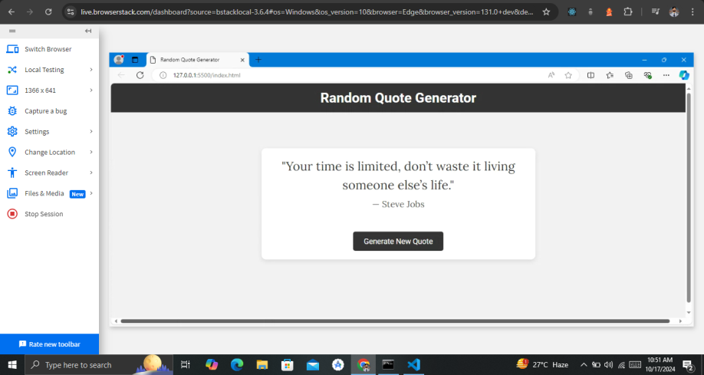

**4. Safari (Version 16.0) – macOS Big Sur**

* **Result**: Passed
* **Observations**: The layout is responsive and adjusts well on different screen sizes. Font rendering is slightly different due to Safari's default behavior, but it doesn’t affect readability.

**5. Google Chrome (Version 117.0) – Android 12**

* **Result**: Passed
* **Observations**: Application is fully responsive on mobile screens. The button is easily clickable, and the quote is legible on small screens.
* 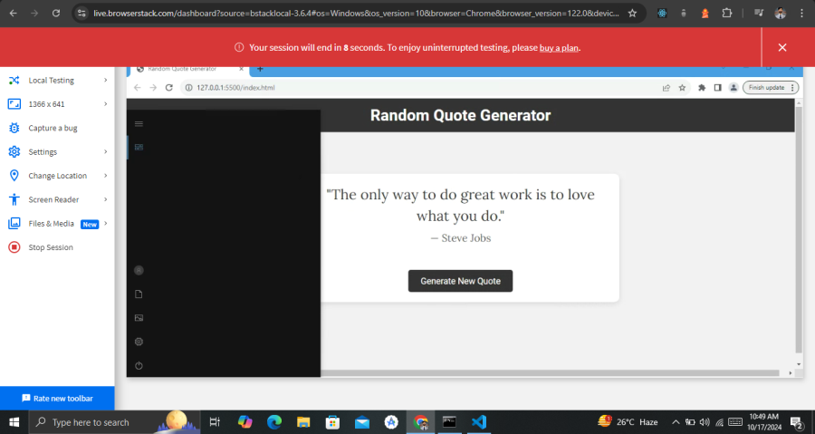

**6. Safari (Version 16.0) – iOS 16**

* **Result**: Passed
* **Observations**: The app works smoothly on iOS. The layout adjusts well to different orientations (portrait and landscape). No significant differences noted compared to desktop versions.

**Conclusion:**

The Random Quote Generator application has been tested across several browsers and devices. It performs consistently with no major issues. The application is fully functional, responsive, and visually consistent across different platforms.